Other news:
Butterflies:
are on the wing in small numbers with some seven species seen in the last week in March. Most people have had a butterfly recording form, but if you cannot find it add the butterflies to your bird list. We have also started moth trapping on suitable nights. We aim to restart the waterworks moth recording sessions this week.
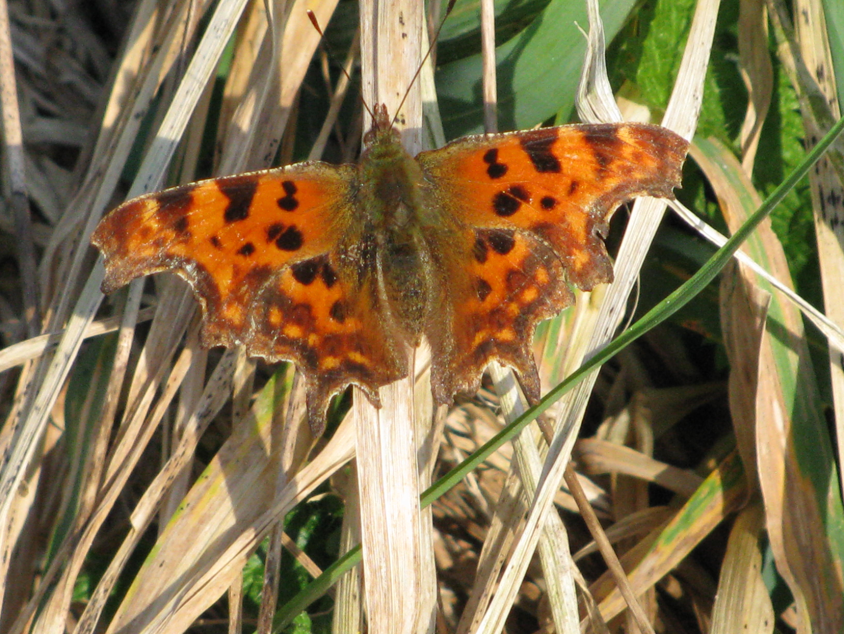
Comma butterfly March 2009 © Janet Craig
Have you a garden pond? David Emery has Great Crested-newts and it is considered very probable that one other garden has newts on Mission Hall Lane. We are obtaining Recording forms for garden reptiles and amphibians, so please keep a note. If you would like your garden pond surveying contact David on 832907.

Wildflowers are starting to bloom. A number of verges have Primrose and Sweet Violet. A full survey of the waterworks wood will start during Easter, especially noting the old trees. If you want to learn more about wildflowers contact John Newbould on 837384. You may also use the number to check on moth evenings on Fridays or Saturdays.

SUTTON POYNTZ BIODIVERSITY GROUP NEWS

Garden Bird Watch March 2009.

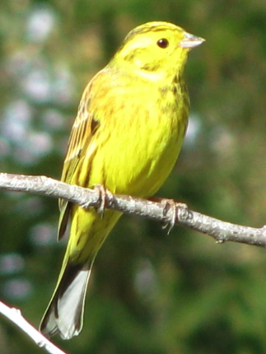
Yellowhammer on the garden bird list March 2009 © Janet Craig
Thank you for retuning forms promptly. In a quick summary we had a total of 38 species (36) with 193 records (147) averaging 16 (15) per garden. Three new gardens joined the scheme. There was just one record of Swallow and impressively two sightings of Barn Owl along Sutton Road. Yellowhammer has continued to visit gardens with records from five gardens. Dartford Warbler is present by Margaret’s Seat.

Many birds are now pairing up. Watch for signs of nesting including carrying materials or feeding. On Mondays we have been standing in
The water works meadow learning bird song and watching for breeding. Birds seen including Treecreeper, Blackcap and Sparrowhawk. | 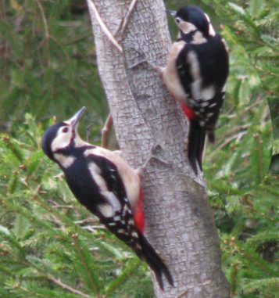
 | Great Spotted Woodpecker March 2009 © Janet Craig

